Weekly Letter 3
August 28-September 1
English I Honors – Beery
DID YOU GET The Pen Commandments? If not, please order it ASAP!
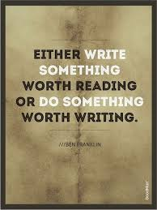
Welcome back to class. This week will challenge you to read, write, and speak----all the pillars of class. Additionally, we will discuss the powerhouses of writing: argument, expository, narrative, and description. Stephen King, a popular novelist, says that in order to be a writer we must bring the right tools for the job. Therefore, this week we will begin to fill up your “toolbox” with the proper tools to build great pieces of writing Furthermore, we will discuss the tools needed to write an expository essay

This week we will be putting our knowledge to work and improve our reading, speaking, and writing skills. Moreover, I want you to think like a writer. Bring the tools you need to build a good piece of writing and use the language of writing to workshop with one another this week and in the future. I know this is one more step to your empowerment as a learner this year.

M Independent Reading and Reading Log----(15 minutes)
Weekly Letter
Distribute seminar information packet and rubric
Discussion in the dictionary is "a close examination of a subject with interchange of opinions, sometimes using argument, in an effort to reach an agreement. Tenents of discussion:
  - Is collaborative
  - One listens to find common ground
  - Enlarges points of view
  - Reveals assumptions for re-evaluation
  - Creates an open-minded attitude
  - Expects other’s reflections will improve their own thinking
  - Temporarily suspending one's beliefs
  - Searches for strengths
  - Respects others and seeks not to alienate
  - Assumes that cooperation can lead to greater understanding
  - Remains open-ended

Benefits of Socratic Seminar include:
- Time to engage in in-depth discussions, problem solving, and clarification of ideas
- Building a strong, collaborative work culture
- Enhanced knowledge and research base
- Increased success for all students
- Teaching respect for diverse ideas, people, and practices

HMWK: Complete Chart for Socratic Seminar: Information includes: Boy 21, Eastleigh, “Illusion”, “On The Rainy River”, selections from “This I Believe”. Bring completed chart to class on Wednesday (it will be turned in on Google Classroom before class on Wednesday to show you are prepare for seminar.---Also, tomorrow is picture day. Bring your picture form to class tomorrow.
T: Picture Day: 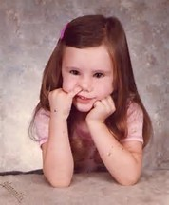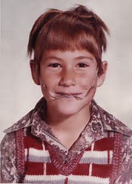
Report to class first and we will go to auditorium together.
Discussion about writing and writing tools/techniques “Make a toolbox”
-Definition of expository writing
-Intro-lead, Background info thesis, Topic Sentence, TE (nuanced), COMM (commentary), conclusion (review format—double chunk)
HMWK: Read : Chapters 1 & 2 of The Pen Commandments and make a list of 4 helpful tips Steven Frank suggests to improve your writing process.----did you turn in chart on Google Classroom for the seminar tomorrow?

W Socratic Seminar: Question: How texts speak to one another and how does this conversation reveal aspects of humanity?
HMWK: Read : Chapter 5 of The Pen Commandments and make a list of 3 helpful tips Steven Frank suggests to improve your writing process.----& read chapter 8 of The Pen Commandments and type a one page, double-spaced reaction paper—Post on Google Docs
A reaction paper means pulling one or two ideas from the text (TE) and reacting to them in writing. Analyze what you think about, what it reminds you of, when it worked or didn’t work, how you might apply advice----------------PLEASE NO SUMMARIES.

TH: On Demand Essay: On-demands will always be handwritten----bring a pen
HMWK: Bring independent reading book tomorrow to class ☺

F Independent Reading and Reading Log----(15 minutes)
Collect reaction paper
Approaching the essay:” Though Shalt Not Take Essay Test in Pain”
Taking essay to the next step. (review journal from Boy 21)
Learning about expository writing: Lead, Body & Conclusion:
Hmwk: bring new rewrite of journal in by Monday----------------highlight changes and be ready to discuss
How you improved your writing.

